How to create App Registration.

Description: Azure App Registration is the process of registering your application with Azure Active Directory (Azure AD). This registration provides your application with the necessary credentials to securely access Azure services and APIs, making your applications and services more secure and accessible.

* Login to Azure cloud portal and Search for – Entra ID and click Microsoft Entra ID

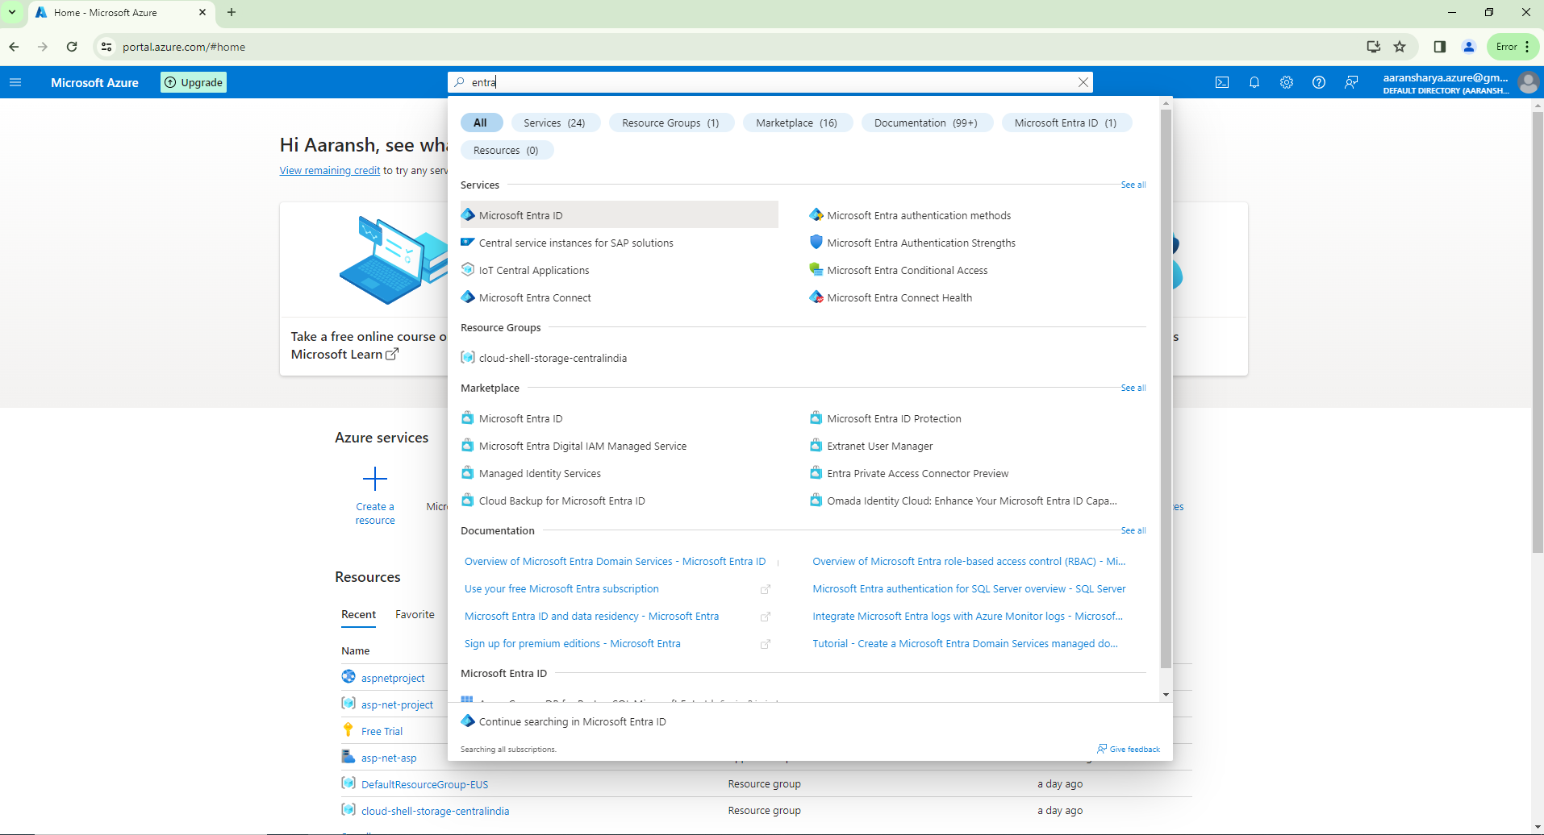

* Click on add

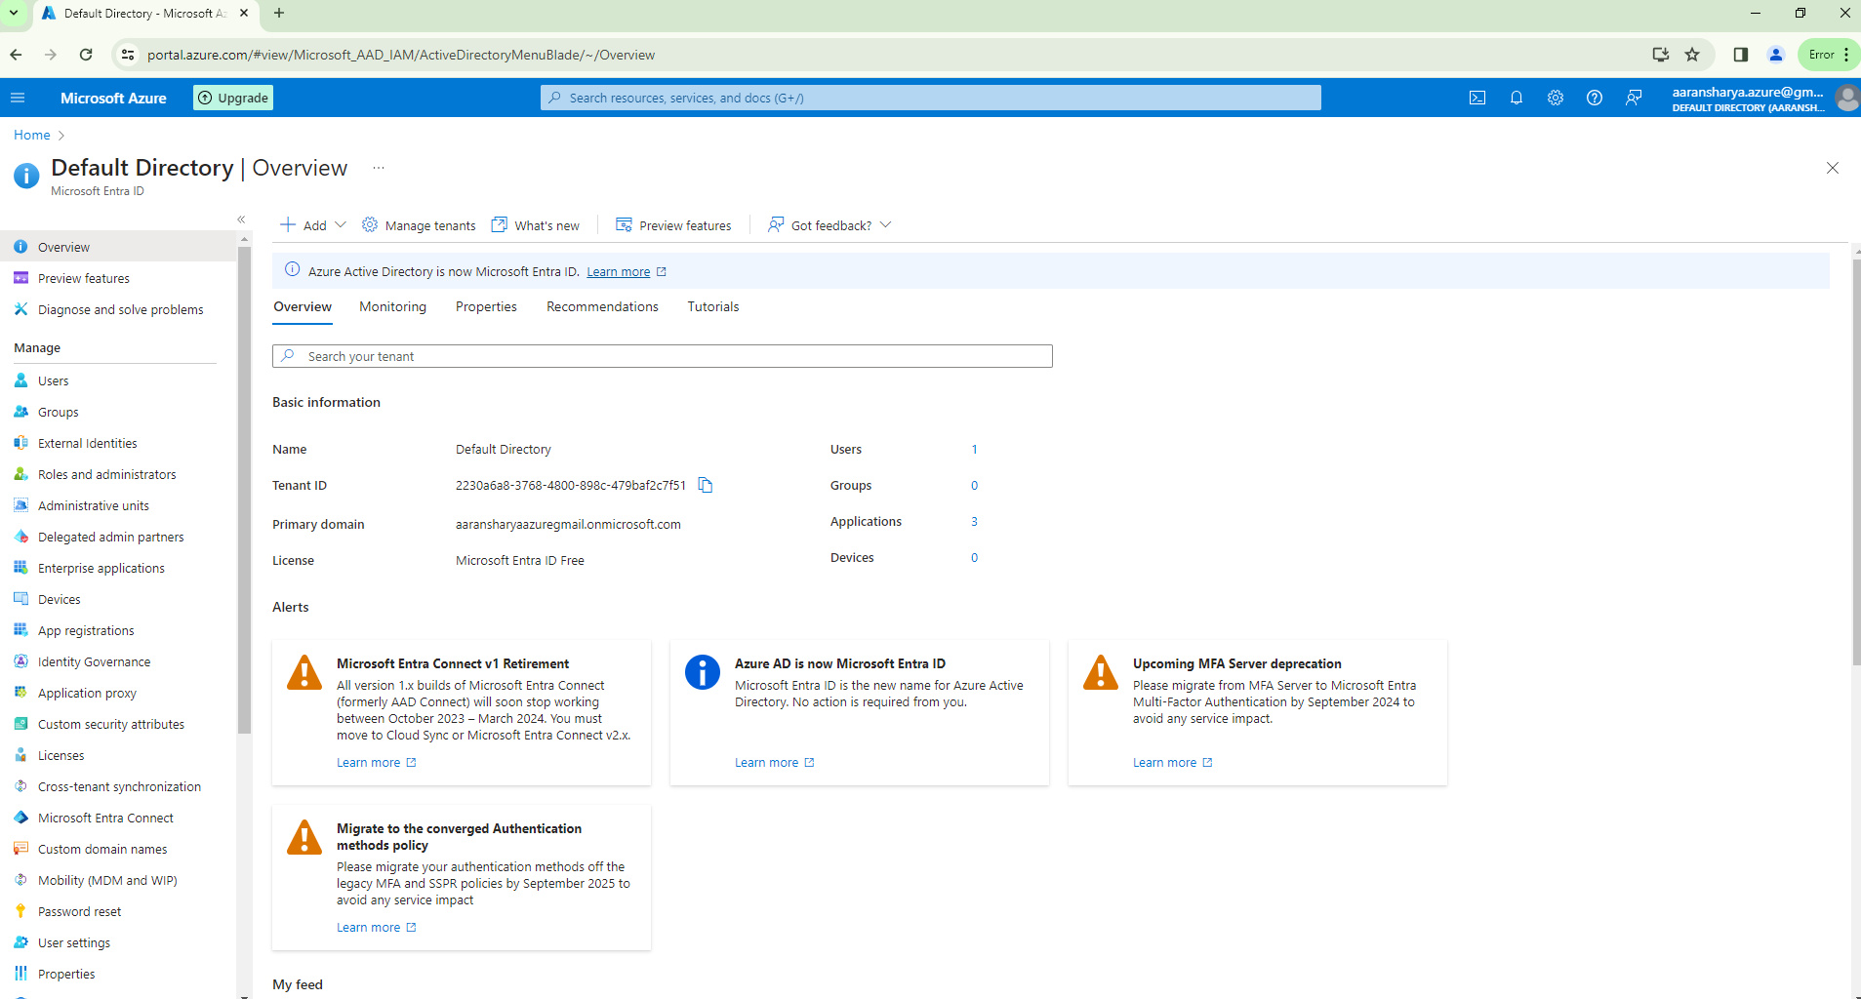

* Click on App Registration.

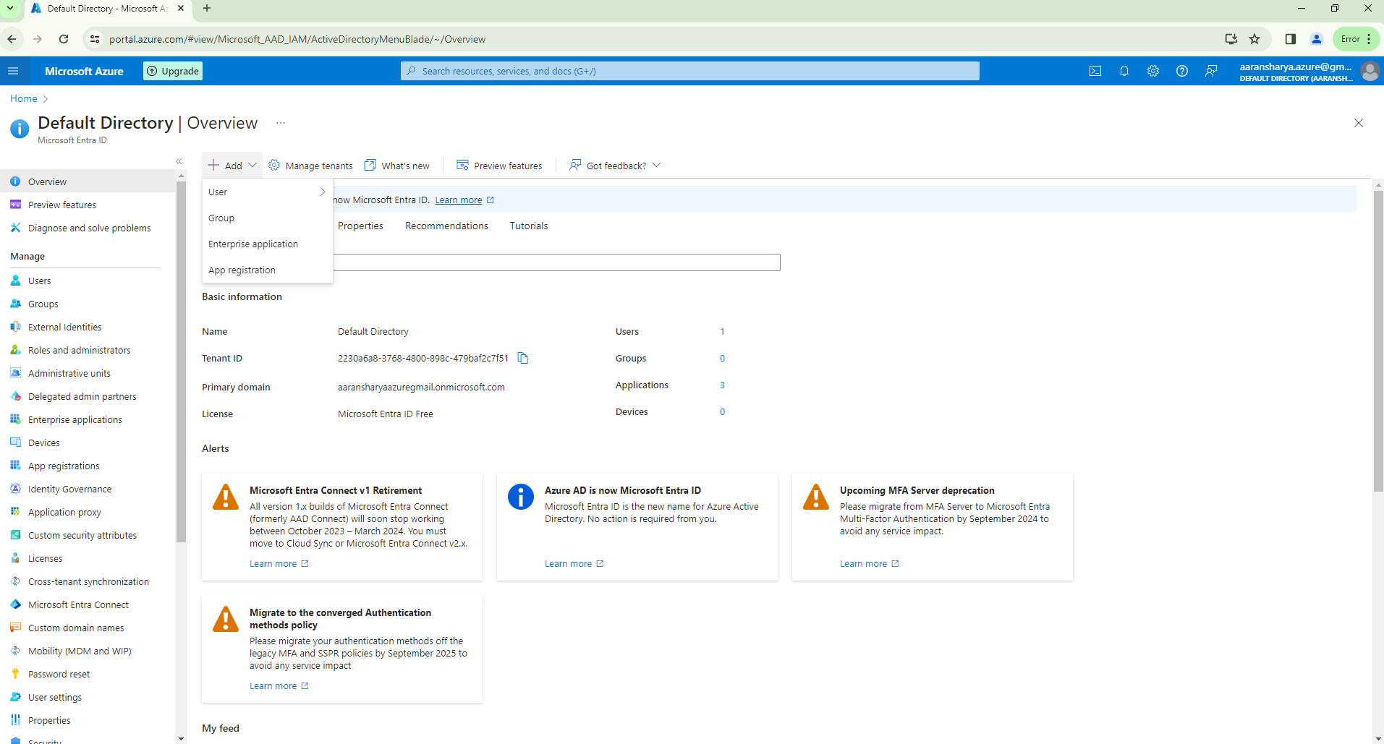

* Give the name to the App registration
* Supported account types – default
* Click on Register

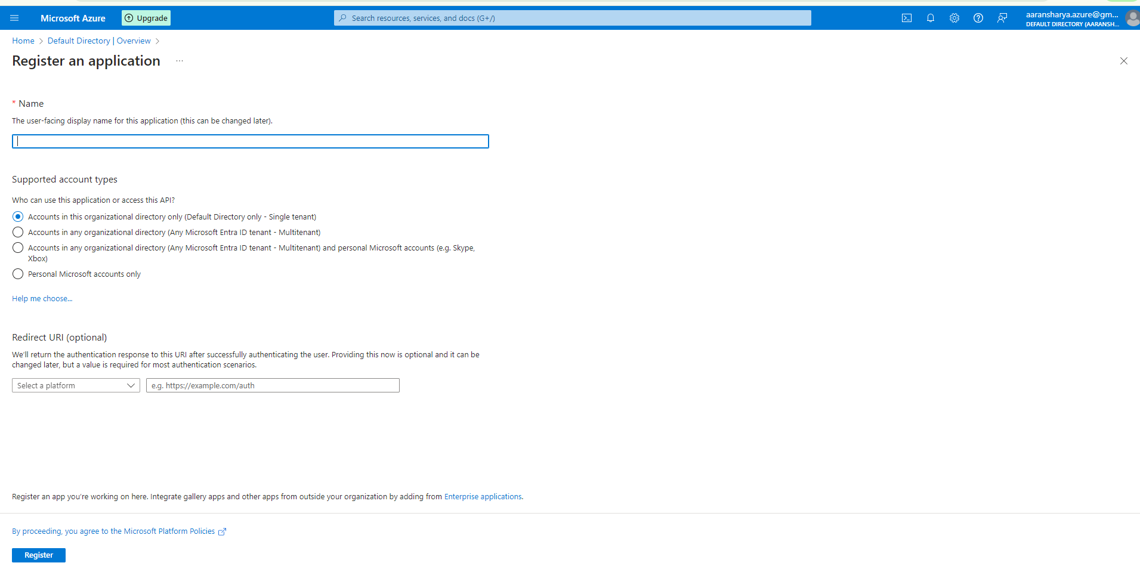

* App registration created

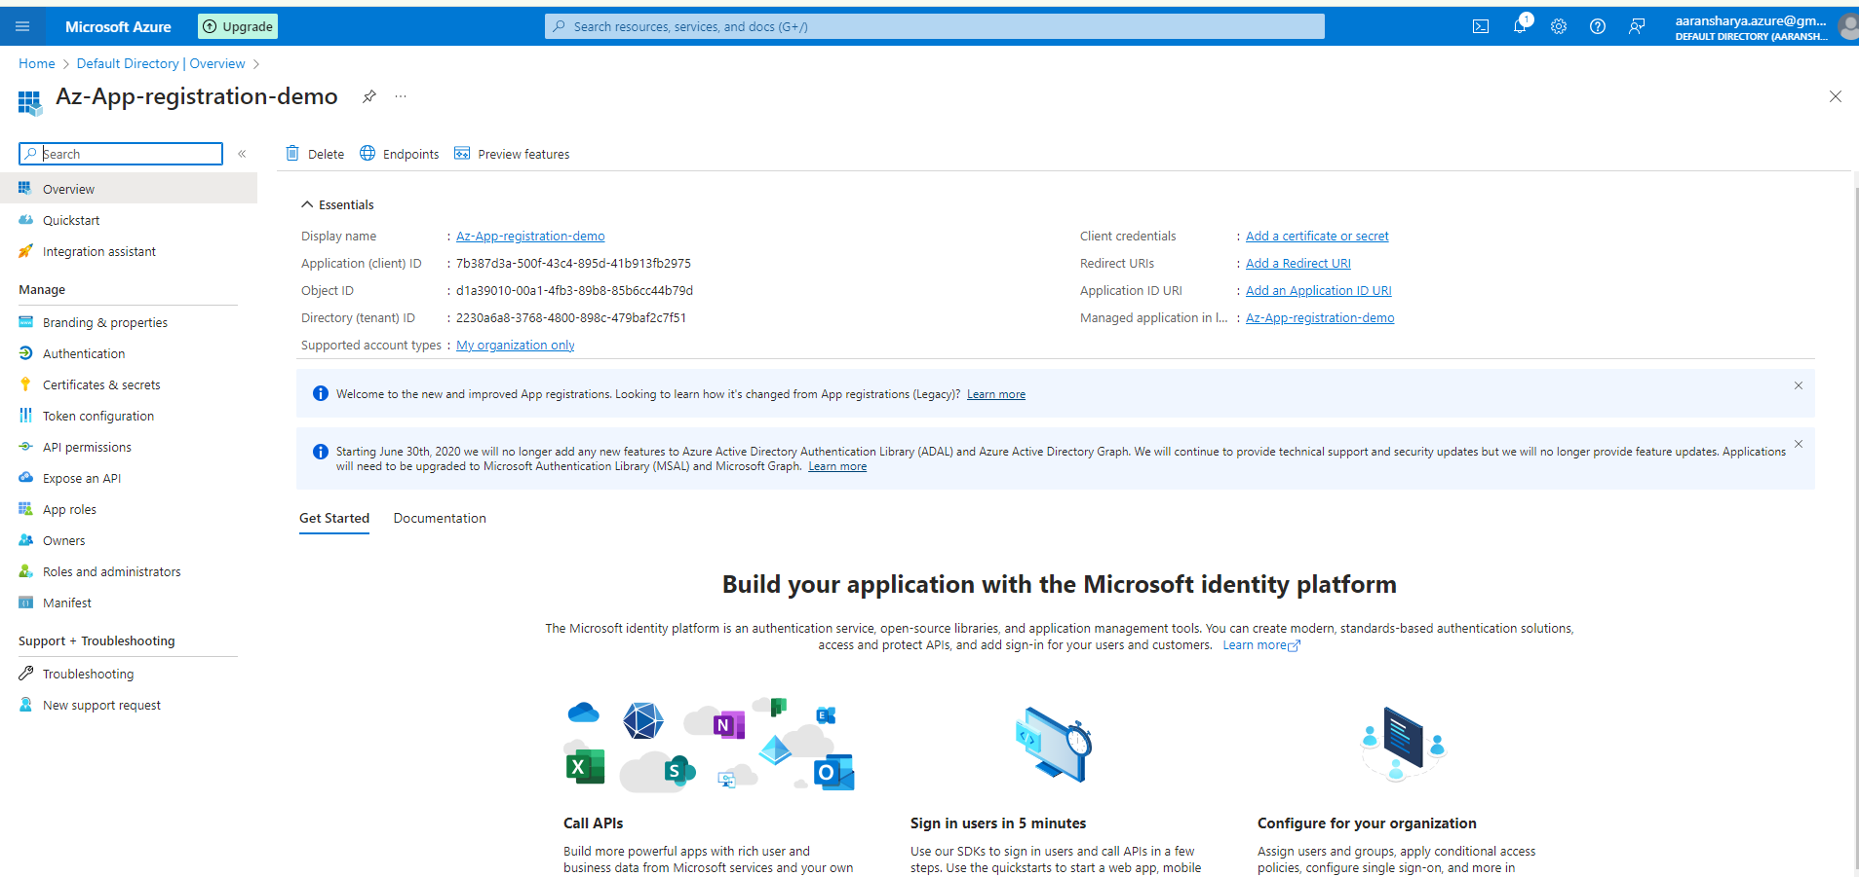

* Then we need to go over the Certificate and Secrets (on menu side)
* Click on the tab Certificate and Secrets

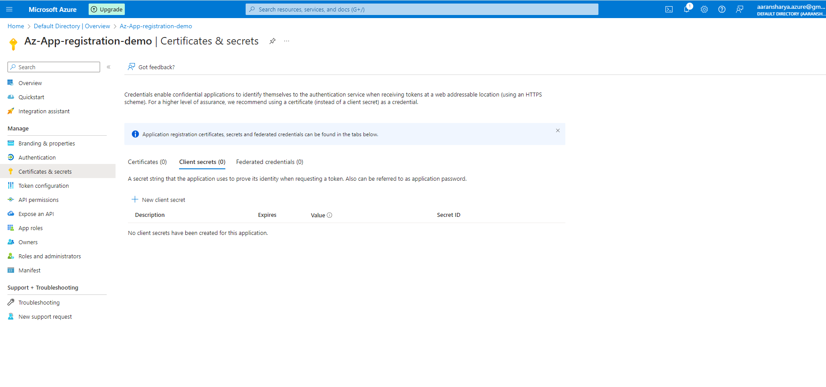

* Click on New client secret

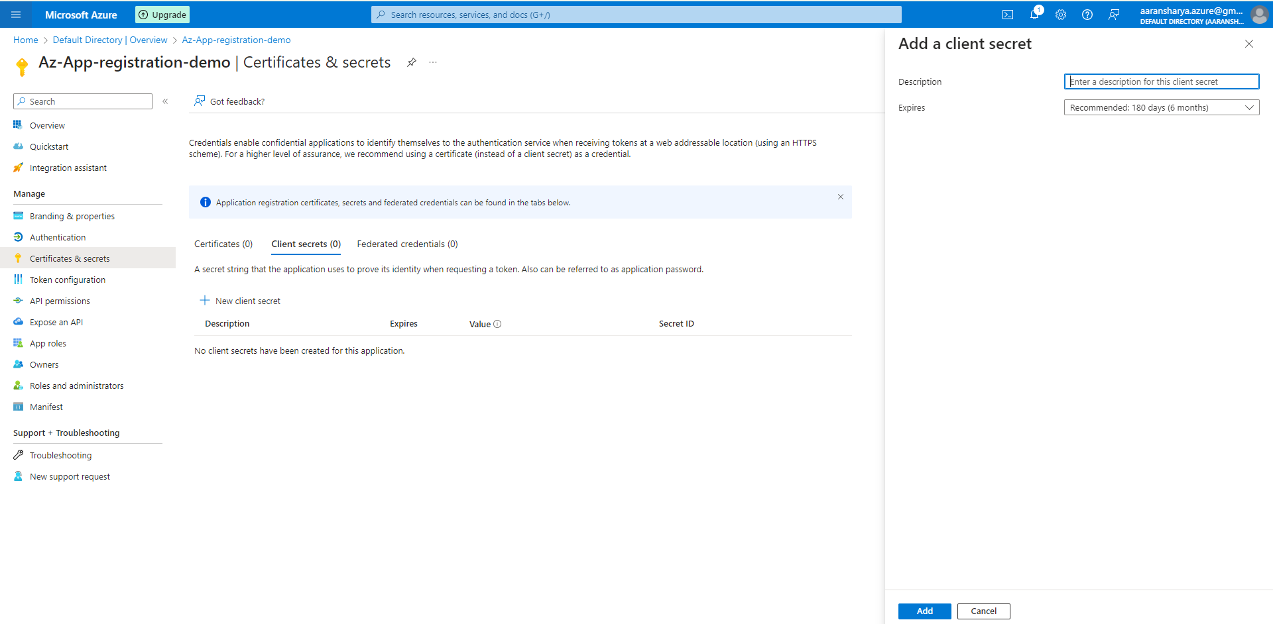

* Give name to the client secret

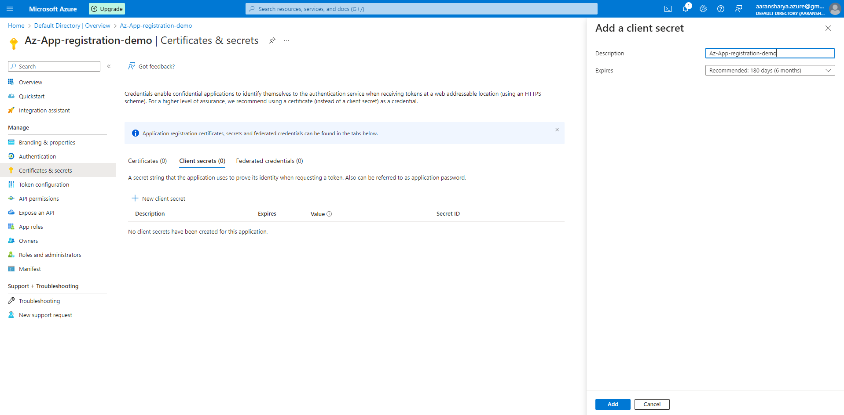

* Click on Add

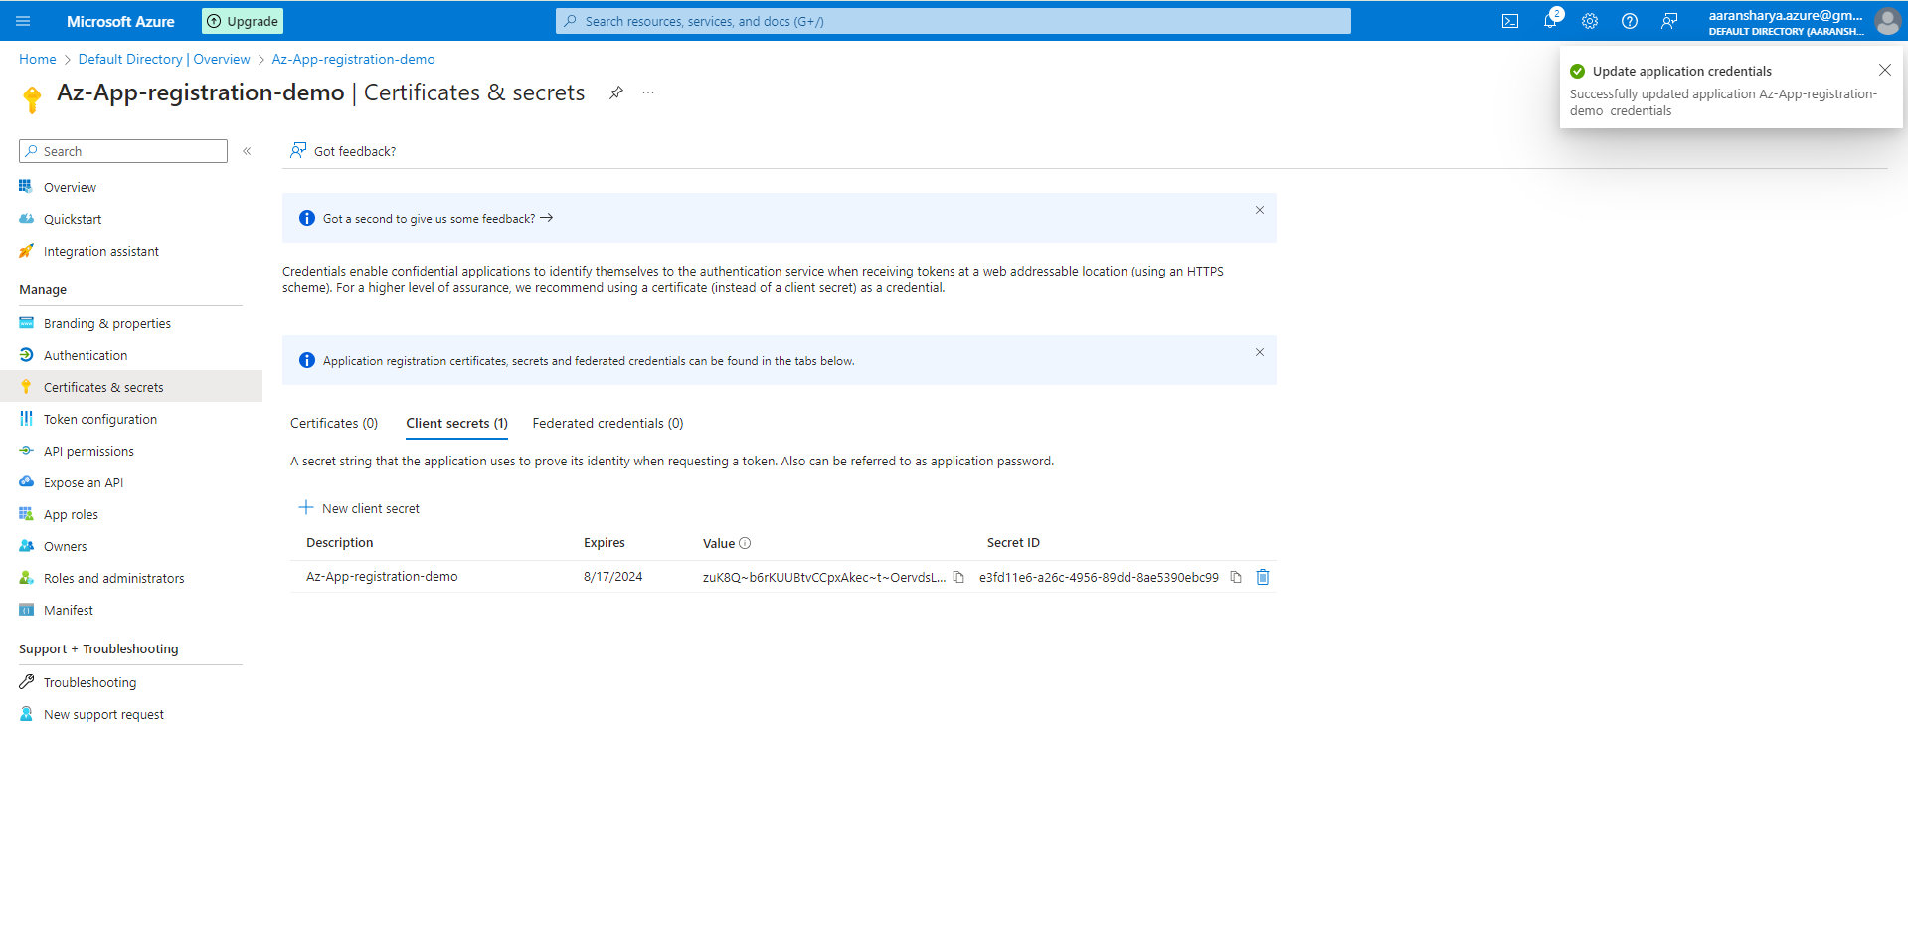

* Certificates and secrets created

\*Note: Copy the value of secret once created as it will available to be copied till page refreshes.